**Jimple code of Vending Machine**

1. i0 := @parameter0: int
2. i1 := @parameter1: int
3. i2 := @parameter2: int
4. i3 := @parameter3: int
5. i4 := @parameter4: int
6. if i0 != 1 goto (branch)
7. if i1 != 1 goto (branch)
8. if i2 != 0 goto (branch)
9. if i3 != 1 goto (branch)
10. if i4 != 0 goto (branch)
11. return 1
12. if i3 != 0 goto (branch)
13. if i4 != 1 goto (branch)
14. return 2
15. if i3 != 0 goto return 10
16. if i4 != 0 goto return 10
17. return 3
18. return 10
19. if i2 != 1 goto (branch)
20. if i1 != 0 goto (branch)
21. if i3 != 1 goto (branch)
22. if i4 != 0 goto (branch)
23. return 4
24. if i3 != 0 goto (branch)
25. if i4 != 1 goto (branch)
26. return 5
27. if i3 != 0 goto return 10
28. if i4 != 0 goto return 10
29. return 3
30. return 10
31. if i2 != 0 goto return 10
32. if i1 != 0 goto return 10
33. if i3 != 1 goto return 3
34. if i4 != 1 goto return 3
35. return 10
36. return 3
37. return 10
38. if i1 != 1 goto (branch)
39. if i2 != 0 goto (branch)
40. if i3 != 1 goto (branch)
41. if i4 != 0 goto (branch)
42. return 6
43. if i3 != 0 goto (branch)
44. if i4 != 1 goto (branch)
45. return 6
46. if i3 != 0 goto return 10
47. if i4 != 0 goto return 10
48. return 7
49. return 10
50. if i1 != 0 goto (branch)
51. if i2 != 1 goto (branch)
52. if i3 != 1 goto (branch)
53. if i4 != 0 goto (branch)
54. return 8
55. if i3 != 0 goto (branch)
56. if i4 != 1 goto (branch)
57. return 9
58. if i3 != 0 goto return 10
59. if i4 != 0 goto return 10
60. return 7
61. return 10
62. if i1 != 0 goto return 10
63. if i2 != 0 goto return 10
64. if i3 != 1 goto return 7
65. if i4 != 1 goto return 7
66. return 10
67. return 7
68. return 10

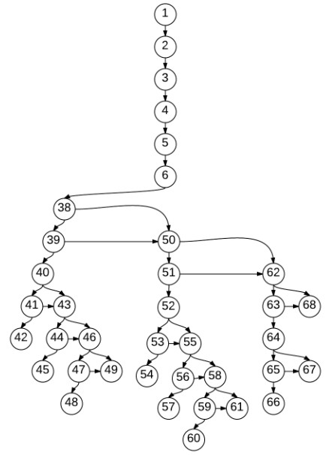**Program Graph**

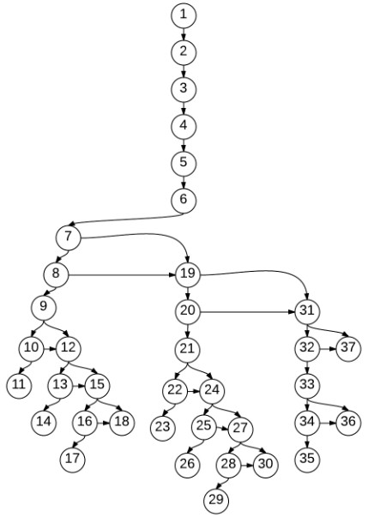

**Decision Extraction**

|  |  |  |
| --- | --- | --- |
| 6 | i0 != 1 | haveChange != 1 |
| 7 | i1 != 1 | oneDollor != 1 |
| 8 | i2 != 0 | fiftyCents != 0 |
| 9 | i3 != 1 | orangeJuice != 1 |
| 10 | i4 != 0 | beer != 0 |
| 12 | i3 != 0 | orangeJuice !=0 |
| 13 | i4 != 1 | beer != 1 |
| 15 | i3 != 0 | orangeJuice !=0 |
| 16 | i4 != 0 | beer != 0 |
| 19 | i2 != 1 | fiftyCents != 1 |
| 20 | i1 != 0 | oneDollor != 0 |
| 21 | i3 != 1 | orangeJuice != 1 |
| 22 | i4 != 0 | beer != 0 |
| 24 | i3 != 0 | orangeJuice !=0 |
| 25 | i4 != 1 | beer != 1 |
| 27 | i3 != 0 | orangeJuice !=0 |
| 28 | i4 != 0 | beer != 0 |
| 31 | i2 != 0 | fiftyCents != 0 |
| 32 | i1 != 0 | oneDollor != 0 |
| 33 | i3 != 1 | orangeJuice !=1 |
| 34 | i4 != 1 | beer != 1 |
| 38 | i1 != 1 | oneDollor != 1 |
| 39 | i2 != 0 | fiftyCents != 0 |
| 40 | i3 != 1 | orangeJuice !=1 |
| 41 | i4 != 0 | beer != 0 |
| 43 | i3 != 0 | orangeJuice !=0 |
| 44 | i4 != 1 | beer != 1 |
| 46 | i3 != 0 | orangeJuice !=0 |
| 47 | i4 != 0 | beer != 0 |
| 50 | i1 != 0 | oneDollor != 0 |
| 51 | i2 != 1 | fiftyCents != 1 |
| 52 | i3 != 1 | orangeJuice !=1 |
| 53 | i4 != 0 | beer != 0 |
| 55 | i3 != 0 | orangeJuice !=0 |
| 56 | i4 != 1 | beer != 1 |
| 58 | i3 != 0 | orangeJuice !=0 |
| 59 | i4 != 0 | beer != 0 |
| 62 | i1 != 0 | oneDollor != 0 |
| 63 | i2 != 0 | fiftyCents != 0 |
| 64 | i3 != 1 | orangeJuice !=1 |
| 65 | i4 != 1 | beer != 1 |

**Feasible Path**

|  |  |  |  |
| --- | --- | --- | --- |
|  | Path | Input | Output |
| 1 | 1,2,3,4,5,6,7,8,9,10,11 | 1 1 0 1 0 | 1 |
| 2 | 1,2,3,4,5,6,7,8,9,12,13,14 | 1 1 0 0 1 | 2 |
| 3 | 1,2,3,4,5,6,7,8,9,12,13,15,16,17 | 1 1 0 0 0 | 3 |
| 4 | 1,2,3,4,5,6,7,8,9,10,12,15,18 | 1 1 0 1 1 | 10 |
| 5 | 1,2,3,4,5,6,7,19,20,21,22,23 | 1 0 1 1 0 | 4 |
| 6 | 1,2,3,4,5,6,7,19,20,21,24,25,26 | 1 0 1 0 1 | 5 |
| 7 | 1,2,3,4,5,6,7,19,20,21,24,25,27,28,29 | 1 0 1 0 0 | 3 |
| 8 | 1,2,3,4,5,6,7,19,20,21,22,24,27,30 | 1 0 1 1 1 | 10 |
| 9 | 1,2,3,4,5,6,7,19,31,32,33,36 | 1 0 0 0 0  1 0 0 0 1 | 3  3 |
| 10 | 1,2,3,4,5,6,7,19,31,32,33,34,36 | 1 0 0 1 0 | 3 |
| 11 | 1,2,3,4,5,6,7,19,31,32,33,34,35 | 1 0 0 1 1 | 10 |
| 12 | 1,2,3,4,5,6,7,8,19,20,31,37 | 1 1 1 0 0  1 1 1 0 1  1 1 1 1 0  1 1 1 1 1 | 10  10  10  10 |
| 13 | 1,2,3,4,5,6,38,39,40,41,42 | 0 1 0 1 0 | 6 |
| 14 | 1,2,3,4,5,6,38,39,40,43,44,45 | 0 1 0 0 1 | 6 |
| 15 | 1,2,3,4,5,6,38,39,40,43,44,46,47,48 | 0 1 0 0 0 | 7 |
| 16 | 1,2,3,4,5,6,38,39,40,41,43,46,49 | 0 1 0 1 1 | 10 |
| 17 | 1,2,3,4,5,6,38,50,51,52,53,54 | 0 0 1 1 0 | 8 |
| 18 | 1,2,3,4,5,6,38,50,51,52,55,56,57 | 0 0 1 0 1 | 9 |
| 19 | 1,2,3,4,5,6,38,50,51,52,55,56,58,59,60 | 0 0 1 0 0 | 7 |
| 20 | 1,2,3,4,5,6,38,50,51,52,53,55,58,59 | 0 0 1 1 1 | 10 |
| 21 | 1,2,3,4,5,6,38,50,51,62,63,64,67 | 0 0 0 0 0  0 0 0 0 1 | 7  7 |
| 22 | 1,2,3,4,5,6,38,50,51,62,63,64,65,67 | 0 0 0 1 0 | 7 |
| 23 | 1,2,3,4,5,6,38,50,51,62,63,64,65,66 | 0 0 0 1 1 | 10 |
| 24 | 1,2,3,4,5,6,38,39,50,62,68 | 0 1 1 0 0  0 1 1 0 1  0 1 1 1 0  0 1 1 1 1 | 10  10  10  10 |

**Statement Coverage**

|  |  |  |  |  |
| --- | --- | --- | --- | --- |
|  |  | Nodes | Input | Output |
| 1 | 1 | 1,2,3,4,5,6,7,8,9,10,11 | 1 1 0 1 0 | 1 |
| 2 | 1,2,3,4,5,6,7,8,9,12,13,14 | 1 1 0 0 1 | 2 |
| 3 | 1,2,3,4,5,6,7,8,9,12,13,15,16,17 | 1 1 0 0 0 | 3 |
| 4 | 1,2,3,4,5,6,7,8,9,10,12,15,18 | 1 1 0 1 1 | 10 |
| 5 | 1,2,3,4,5,6,7,19,20,21,22,23 | 1 0 1 1 0 | 4 |
| 6 | 1,2,3,4,5,6,7,19,20,21,24,25,26 | 1 0 1 0 1 | 5 |
| 7 | 1,2,3,4,5,6,7,19,20,21,24,25,27,28,29 | 1 0 1 0 0 | 3 |
| 8 | 1,2,3,4,5,6,7,19,20,21,22,24,27,30 | 1 0 1 1 1 | 10 |
| 9 | 1,2,3,4,5,6,7,19,31,32,33,36 | 1 0 0 0 0 | 3 |
| 10 | 1,2,3,4,5,6,7,19,31,32,33,34,35 | 1 0 0 1 1 | 10 |
| 11 | 1,2,3,4,5,6,7,8,19,20,31,37 | 1 1 1 0 0 | 10 |
| 12 | 1,2,3,4,5,6,38,39,40,41,42 | 0 1 0 1 0 | 6 |
| 13 | 1,2,3,4,5,6,38,39,40,43,44,45 | 0 1 0 0 1 | 6 |
| 14 | 1,2,3,4,5,6,38,39,40,43,44,46,47,48 | 0 1 0 0 0 | 7 |
| 15 | 1,2,3,4,5,6,38,39,40,41,43,46,49 | 0 1 0 1 1 | 10 |
| 16 | 1,2,3,4,5,6,38,50,51,52,53,54 | 0 0 1 1 0 | 8 |
| 17 | 1,2,3,4,5,6,38,50,51,52,55,56,57 | 0 0 1 0 1 | 9 |
| 18 | 1,2,3,4,5,6,38,50,51,52,55,56,58,59,60 | 0 0 1 0 0 | 7 |
| 19 | 1,2,3,4,5,6,38,50,51,52,53,55,58,59 | 0 0 1 1 1 | 10 |
| 20 | 1,2,3,4,5,6,38,50,51,62,63,64,67 | 0 0 0 0 0 | 7 |
| 21 | 1,2,3,4,5,6,38,50,51,62,63,64,65,66 | 0 0 0 1 1 | 10 |
| 22 | 1,2,3,4,5,6,38,39,50,62,68 | 0 1 1 0 0 | 10 |
| 2 | 1 | 1,2,3,4,5,6,7,8,9,10,11 | 1 1 0 1 0 | 1 |
| 2 | 1,2,3,4,5,6,7,8,9,12,13,14 | 1 1 0 0 1 | 2 |
| 3 | 1,2,3,4,5,6,7,8,9,12,13,15,16,17 | 1 1 0 0 0 | 3 |
| 4 | 1,2,3,4,5,6,7,8,9,10,12,15,18 | 1 1 0 1 1 | 10 |
| 5 | 1,2,3,4,5,6,7,19,20,21,22,23 | 1 0 1 1 0 | 4 |
| 6 | 1,2,3,4,5,6,7,19,20,21,24,25,26 | 1 0 1 0 1 | 5 |
| 7 | 1,2,3,4,5,6,7,19,20,21,24,25,27,28,29 | 1 0 1 0 0 | 3 |
| 8 | 1,2,3,4,5,6,7,19,20,21,22,24,27,30 | 1 0 1 1 1 | 10 |
| 9 | 1,2,3,4,5,6,7,19,31,32,33,34,36 | 1 0 0 0 1 | 3 |
| 10 | 1,2,3,4,5,6,7,19,31,32,33,34,35 | 1 0 0 1 1 | 10 |
| 11 | 1,2,3,4,5,6,7,8,19,20,31,37 | 1 1 1 1 0 | 10 |
| 12 | 1,2,3,4,5,6,38,39,40,41,42 | 0 1 0 1 0 | 6 |
| 13 | 1,2,3,4,5,6,38,39,40,43,44,45 | 0 1 0 0 1 | 6 |
| 14 | 1,2,3,4,5,6,38,39,40,43,44,46,47,48 | 0 1 0 0 0 | 7 |
| 15 | 1,2,3,4,5,6,38,39,40,41,43,46,49 | 0 1 0 1 1 | 10 |
| 16 | 1,2,3,4,5,6,38,50,51,52,53,54 | 0 0 1 1 0 | 8 |
| 17 | 1,2,3,4,5,6,38,50,51,52,55,56,57 | 0 0 1 0 1 | 9 |
| 18 | 1,2,3,4,5,6,38,50,51,52,55,56,58,59,60 | 0 0 1 0 0 | 7 |
| 19 | 1,2,3,4,5,6,38,50,51,52,53,55,58,59 | 0 0 1 1 1 | 10 |
| 20 | 1,2,3,4,5,6,38,50,51,62,63,64,67 | 0 0 0 0 1 | 7 |
| 21 | 1,2,3,4,5,6,38,50,51,62,63,64,65,66 | 0 0 0 1 1 | 10 |
| 22 | 1,2,3,4,5,6,38,39,50,62,68 | 0 1 1 0 1 | 10 |